Deploy RPAPVWStatus Pipeline
Pipeline Name: RPAPVWStatus
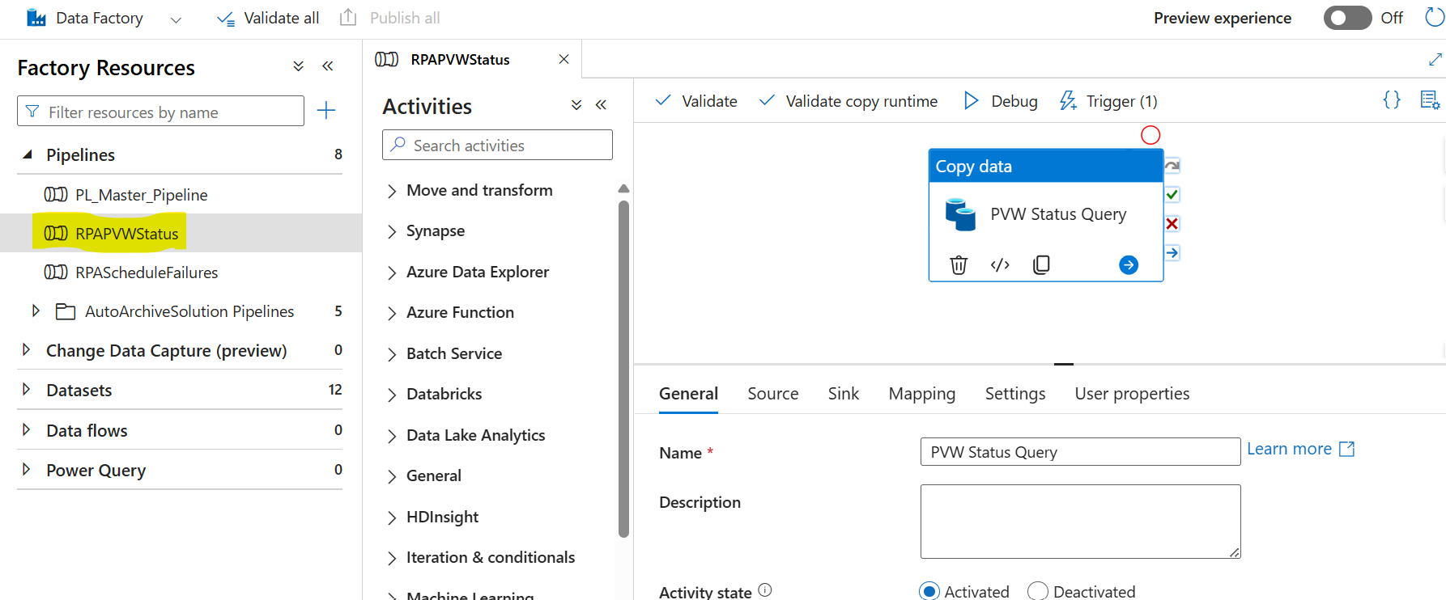

Source
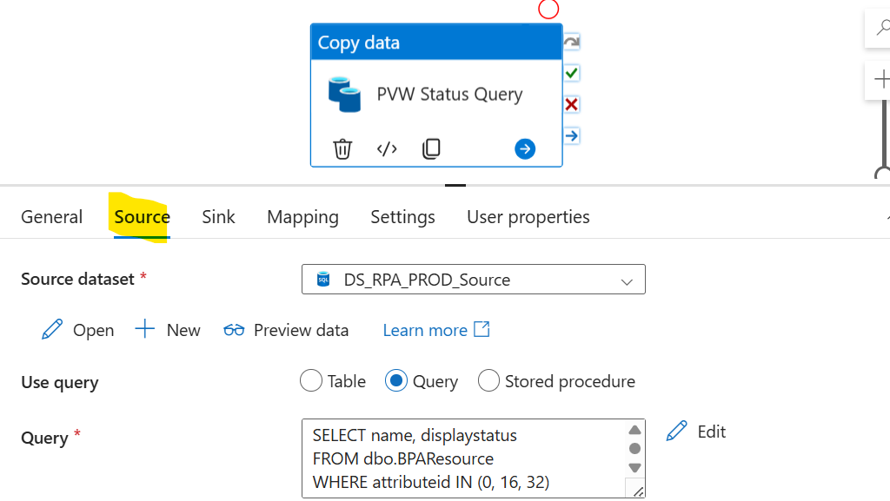
Source Query
SELECT name, displaystatus
FROM dbo.BPAResource
WHERE attributeid IN (0, 16, 32)
ORDER BY
TRY_CAST(SUBSTRING(name, PATINDEX('%[0-9]%', name), LEN(name)) AS INT)
Sink
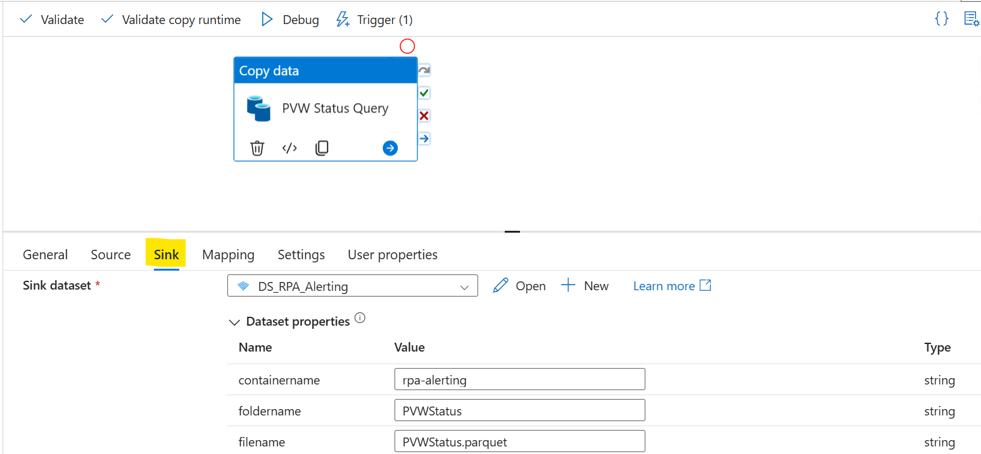

Dataset
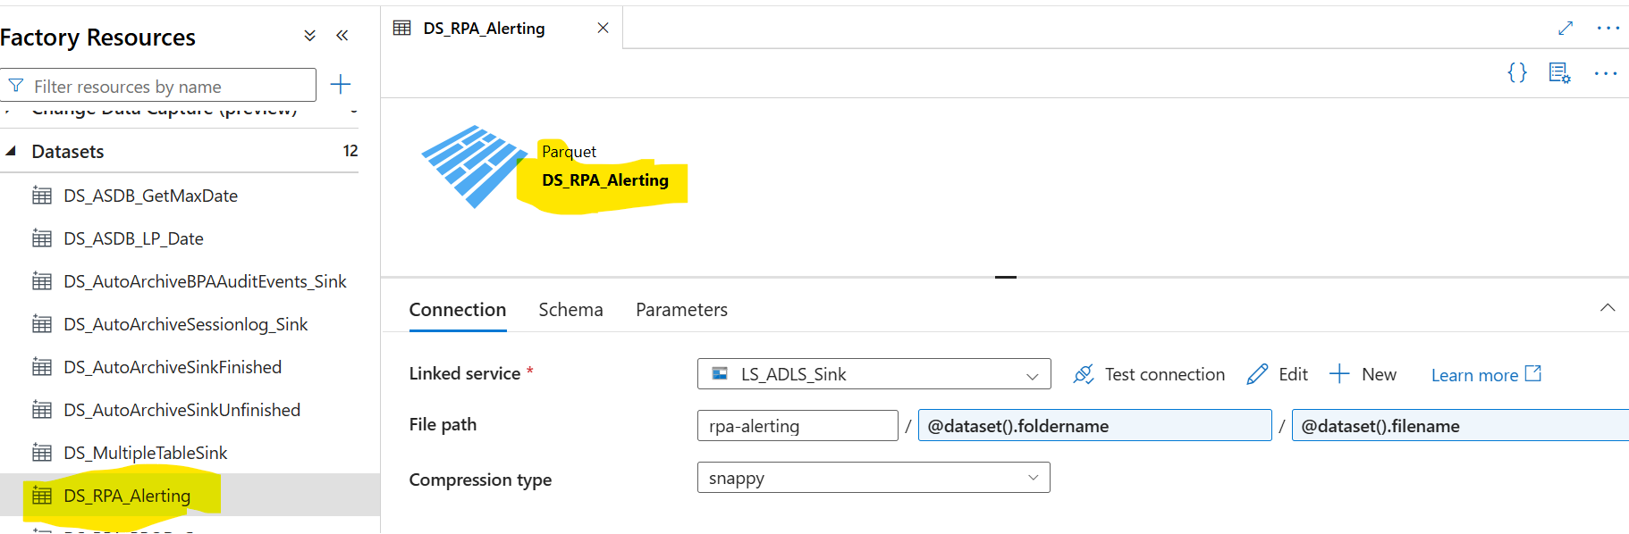

Dataset Parameters
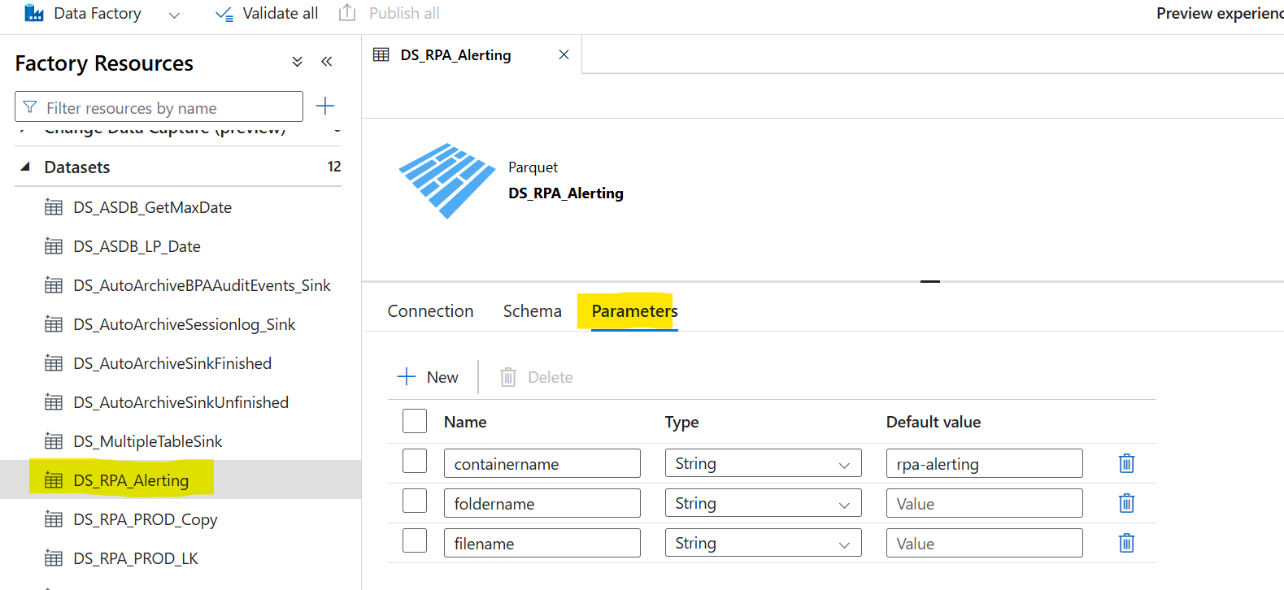

Deploy RPAScheduleFailures Pipeline
Pipeline Name: RPAScheduleFailures

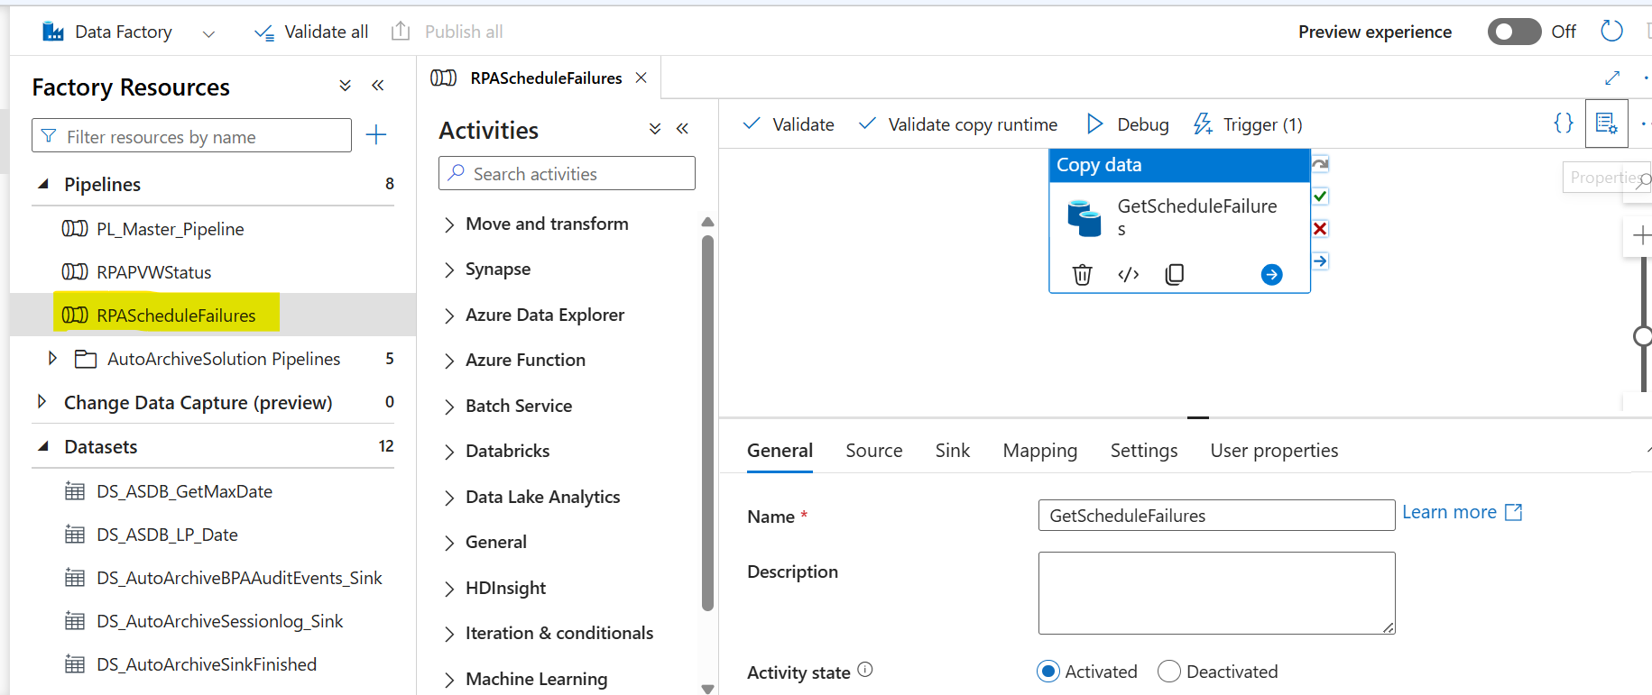

Source
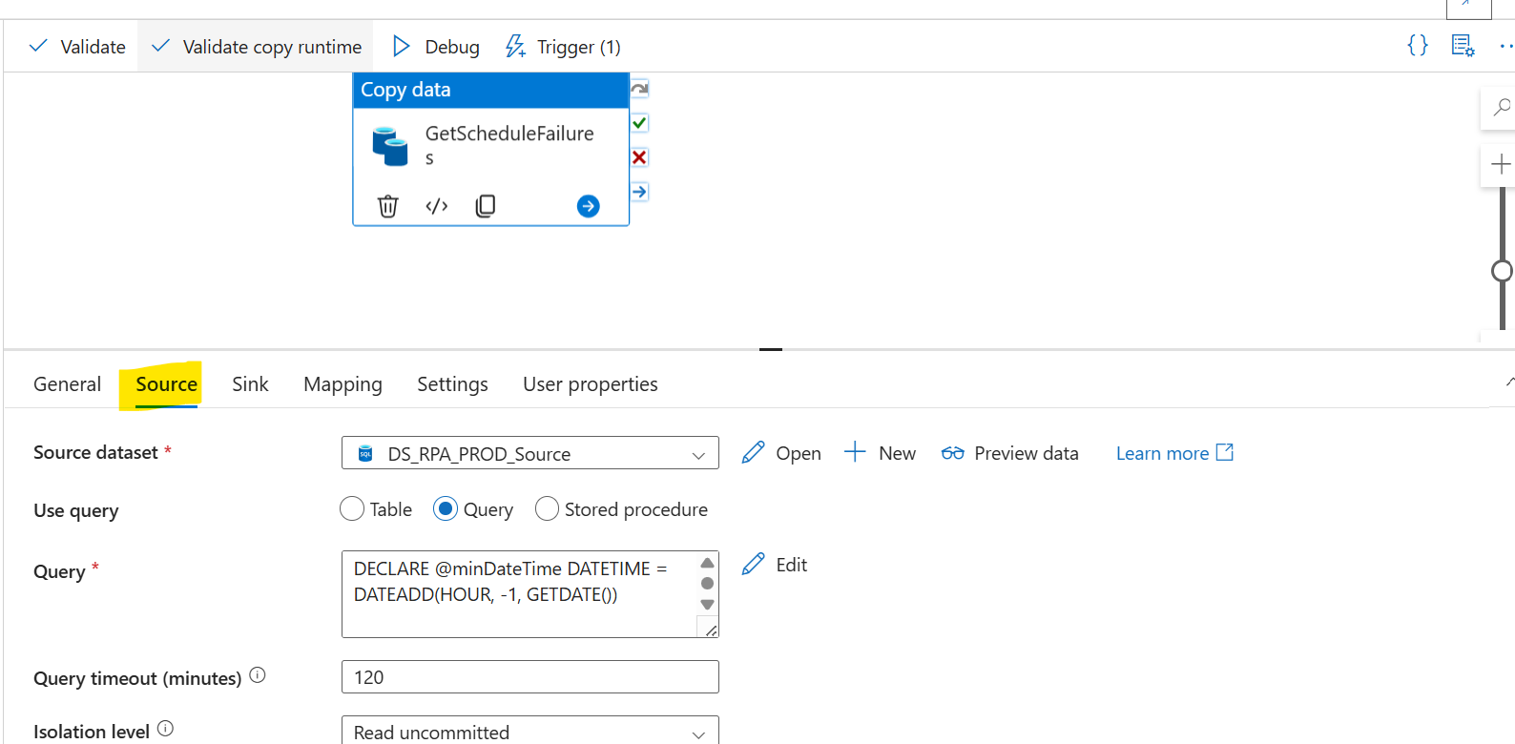

Source Query
DECLARE @minDateTime DATETIME = DATEADD(HOUR, -1, GETDATE())

-- get scheduler-failed schedules
SELECT
s.id AS id
--,sl.id AS scheduleLogId
,s.name AS name
,s.deletedname AS deletedName
,s.description AS description
,s.retired AS retired
,sl.instancetime AS instanceTime
,sl.servername AS runtimeResource
,'Scheduler Error' AS errorType
,CASE
WHEN sl.firereason = 0 THEN 'Normal scheduler execution'
WHEN sl.firereason = 1 THEN 'Missed while scheduler not running'
WHEN sl.firereason = 2 THEN 'Missed while timezone changing'
ELSE 'Missed due to indeterminate failure'
END AS errorReason
FROM BPAScheduleLog sl
INNER JOIN BPASchedule s ON s.id = sl.scheduleid
WHERE sl.firereason > 0
AND sl.instancetime >= @minDateTime

UNION

-- get environment-failed schedules
SELECT
s.id AS id
--,sl.id AS scheduleLogId
,s.name AS name
,s.deletedname AS deletedName
,s.description AS description
,s.retired AS retired
,sl.instancetime AS instanceTime
,sl.servername AS runtimeResource
,'Environment Error' AS errorType
,sle.terminationreason AS errorMessage
FROM BPAScheduleLog sl
INNER JOIN BPAScheduleLogEntry sle ON sle.schedulelogid = sl.id
INNER JOIN BPASchedule s ON s.id = sl.scheduleid
WHERE sl.firereason = 0
AND instancetime >= @minDateTime
AND sle.terminationreason IS NOT NULL
AND sle.taskid IS NOT NULL
AND sle.schedulelogid NOT IN (
SELECT sle.schedulelogid
FROM BPAScheduleLog sl
INNER JOIN BPAScheduleLogEntry sle ON sle.schedulelogid = sl.id
WHERE sl.firereason = 0
AND instancetime >= @minDateTime
AND sle.terminationreason IS NOT NULL
AND sle.logsessionnumber IS NOT NULL
)

UNION

-- get process-failed schedules
SELECT
s.id AS id
--,sl.id AS scheduleLogId
,s.name AS name
,s.deletedname AS deletedName
,s.description AS description
,s.retired AS retired
,sl.instancetime AS instanceTime
,sl.servername AS runtimeResource
,'Process Error' AS errorType
,sel.result AS errorMessage
FROM BPAScheduleLog sl
INNER JOIN BPAScheduleLogEntry sle ON sle.schedulelogid = sl.id
INNER JOIN BPASessionLog_NonUnicode sel ON sel.sessionnumber = sle.logsessionnumber
INNER JOIN BPASchedule s ON s.id = sl.scheduleid
WHERE sl.firereason = 0
AND instancetime >= @minDateTime
AND sle.terminationreason IS NOT NULL
AND sle.logsessionnumber IS NOT NULL
AND sel.result IS NOT NULL
AND sel.logid IN (
SELECT
MAX(sel.logid) AS logId
FROM BPAScheduleLog sl
INNER JOIN BPAScheduleLogEntry sle ON sle.schedulelogid = sl.id
INNER JOIN BPASessionLog_NonUnicode sel ON sel.sessionnumber = sle.logsessionnumber
INNER JOIN BPASchedule s ON s.id = sl.scheduleid
WHERE sl.firereason = 0
AND instancetime >= @minDateTime
AND sle.terminationreason IS NOT NULL
AND sle.logsessionnumber IS NOT NULL
AND sel.result IS NOT NULL
GROUP BY sl.id
);

Sink
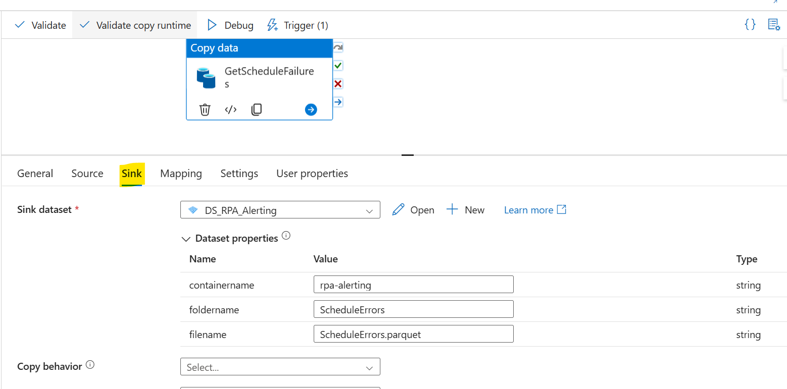

Triggers
